How to add the VirtualHandset .NET library to your project:

1.) In VisualStudio .NET oepn the “Solution Explorer”,
right-click on “References” and select “Add Reference…”

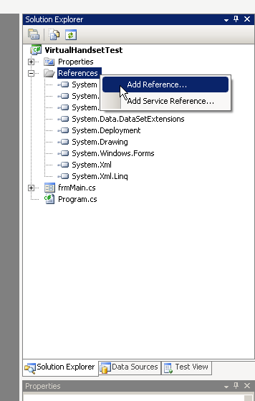

2.) Select the “Browse” tab, navigate to the folder where the library is located (\VirtualHandset .NET 2.0 Library\Library\Release\VirtualHandset.dll) and click OK.
NOTE: You do not need to add the Communication.dll, it will be added automatically.
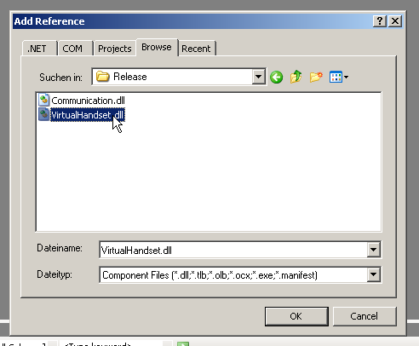

3.) After this, you should find a “VirtualHandset” item in your References folder.
If you see this, you are ready to use the VirtualHandset library in your project.
